

CAPSTONE PROJECT REPORT
Report 3 – Software Requirement Specification

– Hanoi, Aug 2026 –
Table of Contents
Change Log 4
Definition and Acronyms 5
I. Overall Requirements 5
1. Context Diagram 5
2. Main Business Flow 5
2.1 Candidate Self-Service (BF-01) 5
2.2 End-to-End Recruitment (BF-02) 5
2.3 Business Flow Name (Code) 6
3. Conceptual Data Model 6
3.1 Entity Relationship Diagram 6
3.2 Entity Descriptions 6
3.3 Data Business Rules 7
4. User Requirements 8
4.1 Actors 8
4.2 Use Cases (UC) 8
4.3 Use Case Diagrams 9
4.4 Permission Matrix 9
5. System Functionalities 10
5.1 Screen Inventory 10
5.2 External API Inventory 10
5.3 Background Job Inventory 11
II. Use Case Specifications 11
1. <<Feature Name1>> 11
1.1 UC Name1 11
1.2 Login System 12
1.3 UC Name2 12
2. Xyz Feature 12
III. Functional Requirements 13
1. Feature Name1 13
1.1 SubFeature Name1.1 13
1.2 SubFeature Name1.2 13
2. User Authentication 13
2.1 User Register 13
2.2 User Login 13
3. System Administration 14
3.1 System Settings 14
3.2 User Management 15
4. Feature NameN 15
5. Background Job Inventory 15
5.1 Unlock Expired Locked Accounts (JOB-01) 15
5.2 Clean Up Old Audit Log Entries (JOB-02) 15
6. External API Inventory 16
6.1 HTTP Method: URL pattern (API-ID) 16
6.2 VnPay Webhook (API-02) 16
6.3 SePay Webhook (API-03) 16
IV. Non-Functional Requirements 16
1. External Interfaces 16
2. Quality Attributes 16
2.1 Usability 16
2.2 Performance 17
2.3 Security 17
V. Requirement Appendix 17
1. Business Rules 17
2. System Messages 18
3. Other Requirements 18

Change Log
Date | A*  M, D | In charge | Change Description
*A - Added M - Modified D - Deleted

Definition and Acronyms
[Fill all the definitions, acronyms,… used within the whole project in the table format as below]
Acronym | Definition
COS | Cafeteria Ordering System
…

I. Overall Requirements

1. Context Diagram
[Provides the overall description about the product with some introduction and the context diagram]
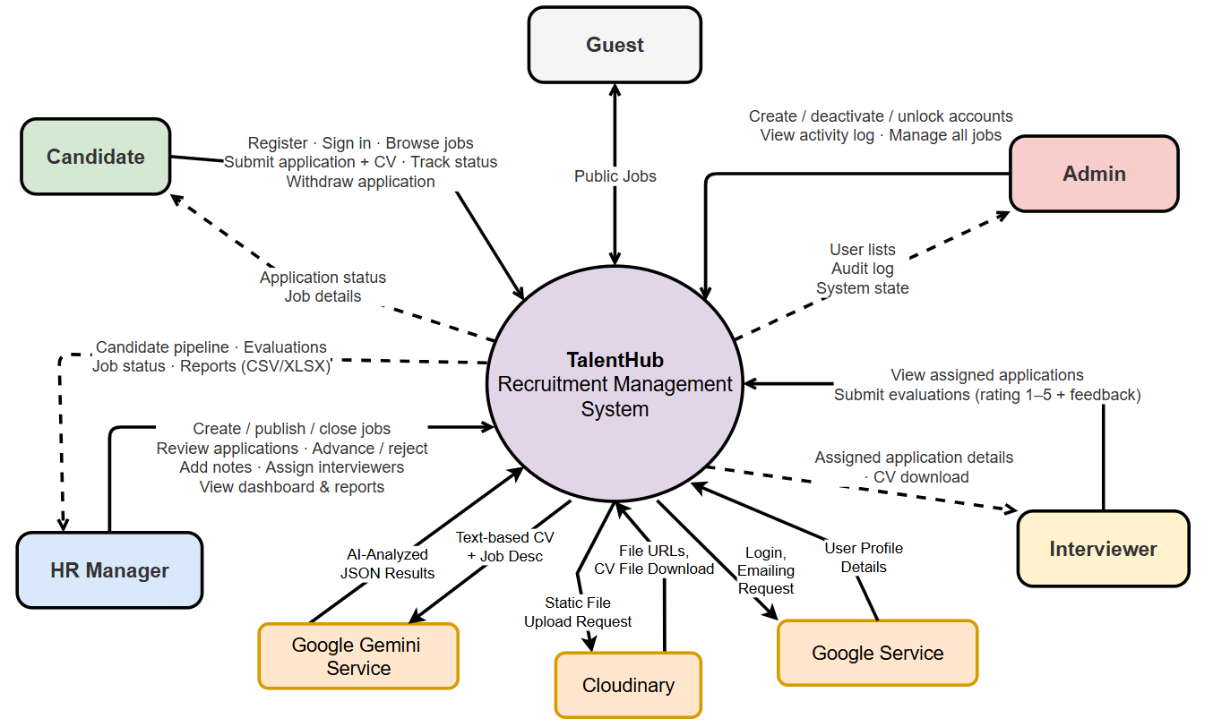

2. Main Business Flow
[List all flows with swimlane diagrams as samples below].

2.1 Candidate Self-Service (BF-01)
Trigger: Candidate creates an account.
End condition: Candidate has seen the final outcome of all applications.
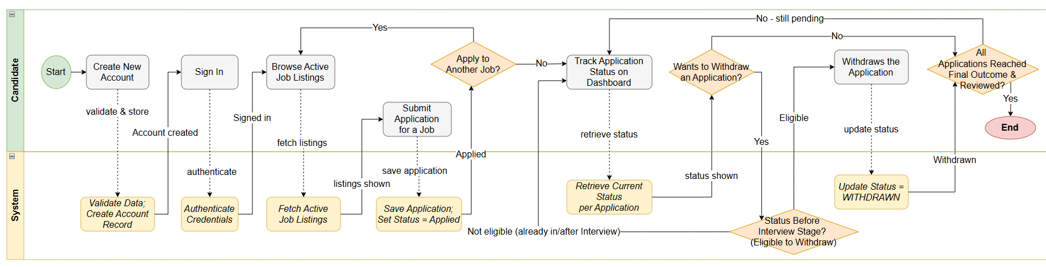

2.2 End-to-End Recruitment (BF-02)
Trigger: HR Manager decides to open a new position and creates a job posting.
End condition: Candidate status reaches HIRED or REJECTED (both terminal).

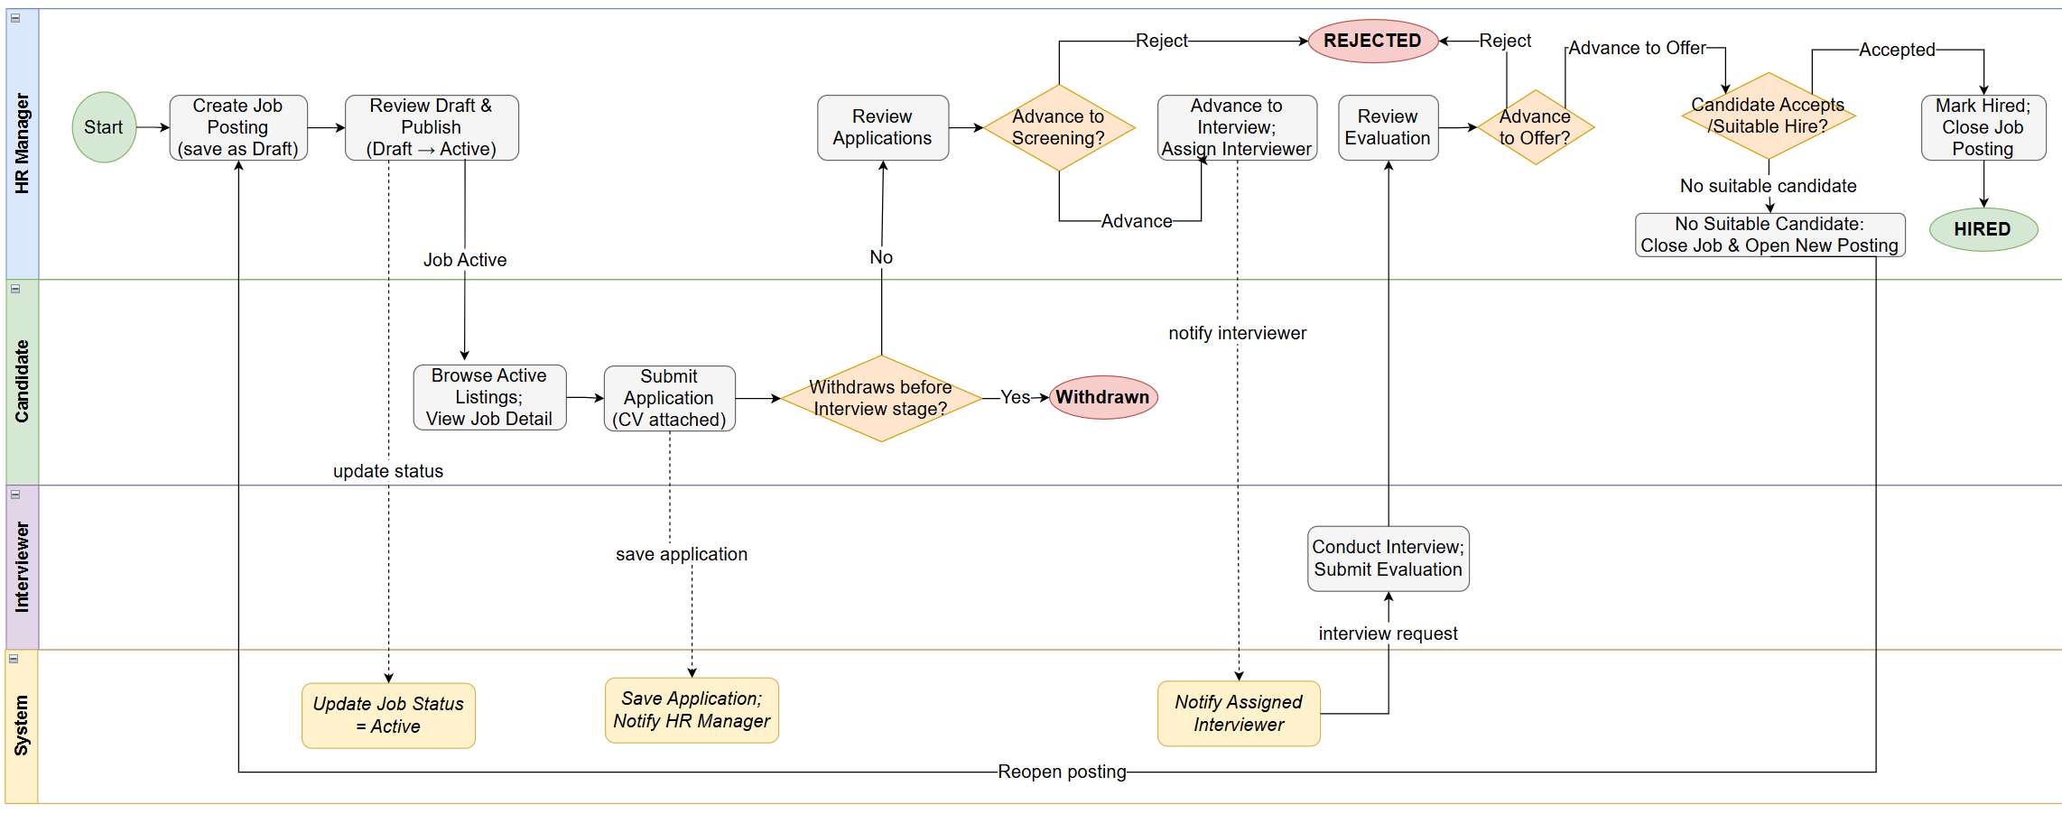

2.3 Business Flow Name (Code)
…

3. Conceptual Data Model

3.1 Entity Relationship Diagram
[Provide the ERD using the Crow-Foot notation and the entity descriptions as below. Relationship labels are business verb-ing]
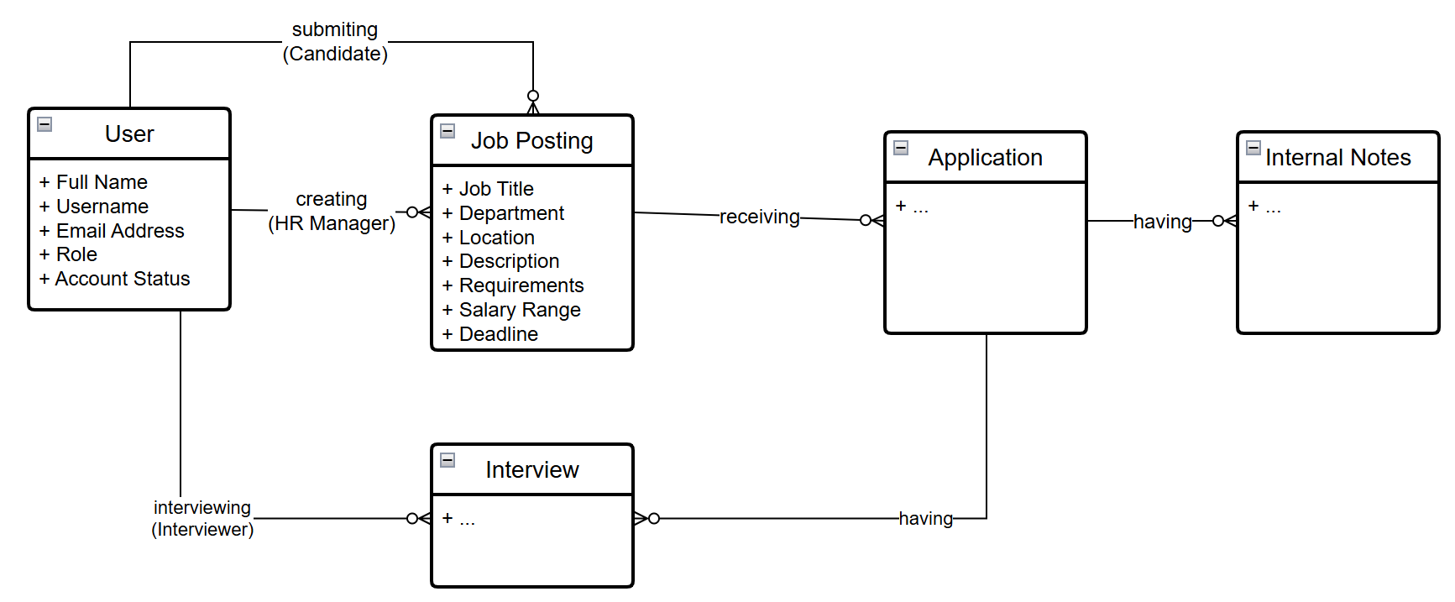

3.2 Entity Descriptions
[Provide one block per entity with descriptions and key business attributes only.]
Entity: User
Field | Value
Purpose | Every person with an account in the system, regardless of role.
Key business attributes | Full name, username, email address, role (Admin / HR Manager / Interviewer / Candidate), account status
Business identity | Username unique across the entire system. Email unique across the entire system.
Status / lifecycle | Active (normal) · Inactive (deactivated by Admin) · Locked (temporary — after repeated failed sign-in attempts)
Entity: Job Posting
Field | Value
Purpose | A job opening created by HR Manager, visible to Candidates when Active.
Key business attributes | Job title, department, location, job description, requirements, salary range (optional), application deadline
Business identity | No natural unique key. Multiple postings with the same title in the same department are permitted.
Status / lifecycle | Draft → Active → Closed (one-way)
Entity: Application
Field | Value
Purpose | A Candidate's expression of interest in a specific Job Posting, with CV attached.
Key business attributes | Which Candidate, which Job Posting, CV file, cover letter (optional), current pipeline stage, submission date
Business identity | A Candidate may submit at most one Application per Job Posting. This combination is unique.
Status / lifecycle | Applied → Screening → Interview → Offer → Hired (terminal) or Rejected (terminal, from any stage); Withdrawn (terminal — Candidate-initiated from Applied or Screening only)
Entities: Internal Note, Interview
[Add one block per additional entity following the same structure.]
Field | Value
Purpose | {{ENTITY_PURPOSE}}
Key business attributes | {{KEY_ATTRIBUTES}}
Business identity | {{BUSINESS_IDENTITY}}
Status / lifecycle | {{STATUS_VALUES}}

3.3 Data Business Rules
[Rules about data that are not obvious from the ERD. ]
Rule | Description | Enforced On
Unique username | No two users may share the same username, regardless of role. | Account creation and username change
Unique email | No two users may share the same email address. | Account creation and email change
One application per job | A Candidate may not submit a second Application for a job they have already applied to, even if the previous was withdrawn. | Application submission
Application requires active job | A Candidate may only apply for a Job Posting with status Active. | Application submission
Accounts never permanently deleted | User accounts are deactivated, not deleted. All associated data must remain accessible. | Account deactivation
Jobs with applications cannot be deleted | A Job Posting with at least one Application (any status) cannot be deleted — must be Closed instead. | Job deletion
Internal notes are permanent | Once saved, an Internal Note cannot be edited or deleted by anyone. They form an audit trail. | Note creation
Evaluations are permanent | Once an Interviewer submits rating and feedback, neither can be changed by anyone. | Evaluation submission
CV files are access-controlled | CV files must never be accessible via a guessable or publicly shareable link. Access verified by system on every download. | CV file access

4. User Requirements

4.1 Actors
[An actor is someone/something that interacts with the system.
- The only external entities that interact with the system
- ﻿Actors are outside the system and not part of it
- ﻿A user is an individual, whereas an actor represents the role played by all users of the same type
- There are other types of actors in addition to or in place of human actors: external systems, I/O devices, or timers
Following are some questions you might ask to help user representatives identify actors
- Who (or what) is notified when something occurs within the system?
- Who (or what) provides information or services to the system?
- Who (or what) helps the system respond to and complete a task?
This part gives the description of system actors, you can follow the table form as below]
# | Actor | Description
1 | Administrator | Actor description here..
2 | Menu Manager | ..
3 | …

4.2 Use Cases (UC)
[A use case (UC) describes a sequence of interactions between a system and an external actor that results in the actor being able to achieve some outcome of value. The names of use cases are always written in the form of a verb followed by an object. Select strong, descriptive names to make it evident from the name that the use case will deliver something valuable for some user.
Following are some questions you might ask to help user representatives identify use cases
- What will the actor use the system for?
- Will the actor create, store, change, remove, or read data in the system?
- Will the actor need to inform the system about external events or changes?
- Will the actor need to be informed about certain occurrences in the system?
This part describes the use cases following the form of the table as below]
ID | Use Case | Feature | Use Case Description
01 | View Menu | Feature Name1
02 | Order a Meal | Feature Name2
03 | …
…

4.3 Use Case Diagrams
In this section, you need to provide the UC diagram(s) to show the actor-UCs and UC-UC relationships like the sample below. You can have multiple UC diagrams for the system, each diagram is for one human actor or one workflow]

4.3.1 UCs for Guest
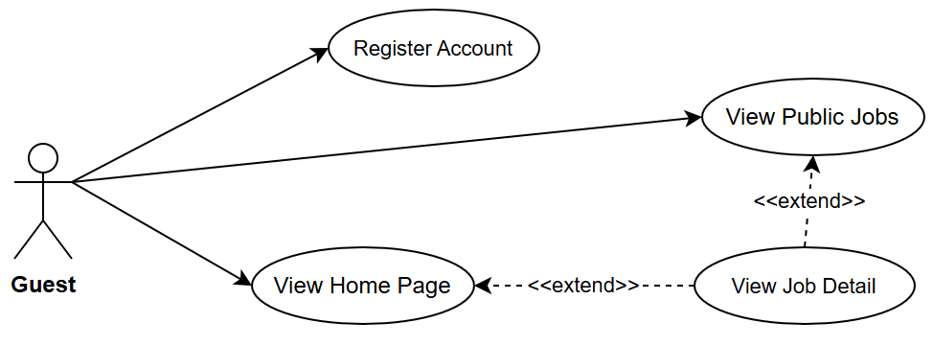

4.3.2 UCs for Candidate
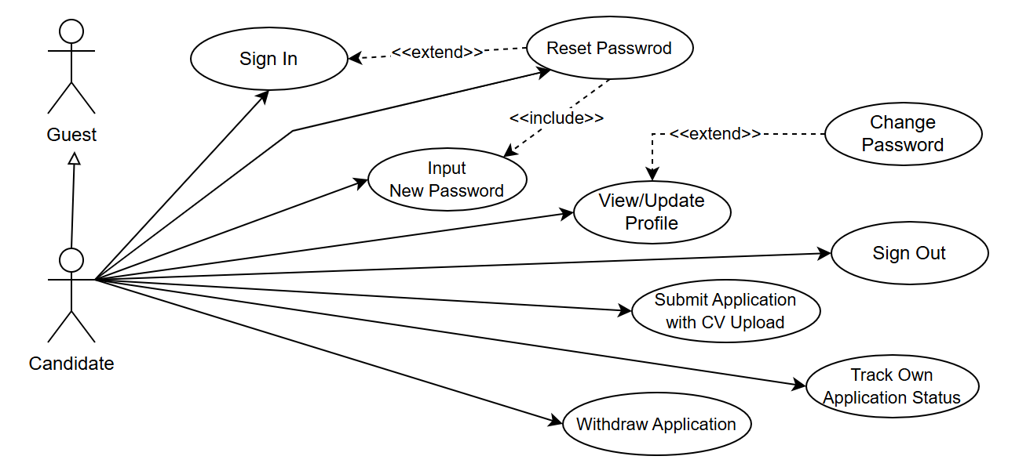

4.3.3 …

4.4 Permission Matrix
Full = unrestricted · Restricted = conditions apply (see footnotes) · No = denied
Entity | Action | Admin | HR Manager | Interviewer | Candidate | Guest
User account | Create | Full | No | No | No | No
User account | Edit / Deactivate | Full | No | No | No | No
User account | Unlock | Full | No | No | No | No
Job posting | Create | Full | Full | No | No | No
Job posting | Edit | Full | Full | No | No | No
Job posting | Delete | Full | Full | No | No | No
Job posting | Change status | Full | Full | No | No | No
Job posting | View (Active only) | Full | Full | Full | Full | Full
Application | Submit | No | No | No | Full | No
Application | View own | No | No | No | Full | No
Application | View all (per job) | Full | Full | Restricted ¹ | No | No
Application | Update status | Full | Full | No | No | No
Application | Withdraw | No | No | No | Full | No
Internal note | Create / View | Full | Full | No | No | No
Interview | Schedule / Assign | Full | Full | No | No | No
Interview | Submit evaluation | Full | Full | Full | No | No
Dashboard | View | Full | Full | No | No | No

5. System Functionalities
[Provide functionality overview of software system]

5.1 Screen Inventory

a. Screen Flow
[This part shows the system screens and the relationship among screens – see sample below]
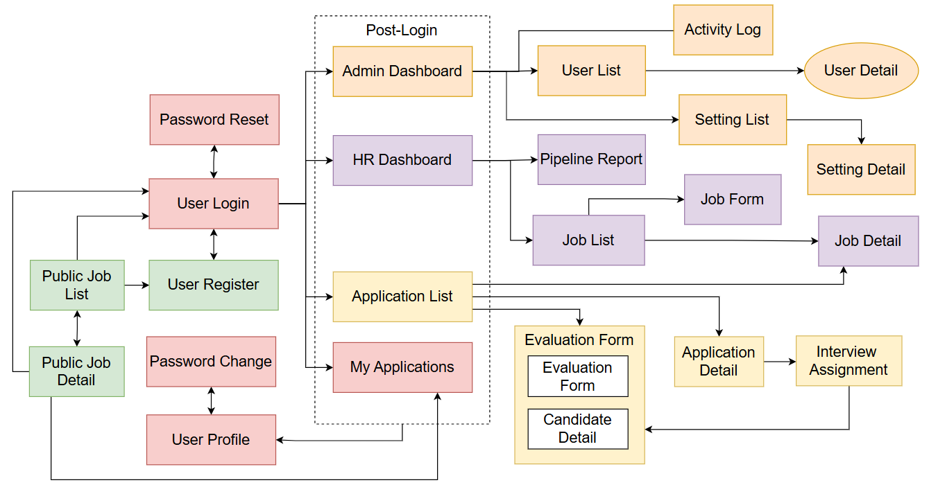

b. Screen List
[Fill details of each screen into the table with the columns and sample data as below]
# | Screen Name | Feature | Description
1 | Sign In | Authentication | Allows any user to authenticate and reach their role-specific area of the system
2 | User Register | Authentication | Allows a new Candidate to create their own account

5.2 External API Inventory
[Fill details of each external API into the table with the columns and sample data as below]
# | API Name | Calling Path | Description
1 | Employee sync API | HRM System → TalentHub | allows an external HR management system to push employee records and automatically create Interviewer accounts
2 | Outbound webhook | TalentHub → External HRM | notifies an external system when a Candidate's status changes to HIRED

5.3 Background Job Inventory
[Fill details of each background job into the table with the columns and sample data as below]
# | Job Name | Group | Description
1 | Unlock expired locked accounts | Scheduled | Every 15 minutes
2 | Clean up old audit log entries | Scheduled | Daily at 2:00 AM

II. Use Case Specifications
[Provide specifications for the use cases (UCs) those are covered in the system. The UCs are grouped by the system features and even sub features. You just need to provide UC specifications for UCs involving in the main workflows (business processes) or the complex ones. Other UCs (i.e CRUD or data-viewing UCs) are simple, and you just need to refer the descriptions in the Functional Requirement (part III) below)]

1. <<Feature Name1>>

1.1 UC Name1
Primary Actors |  | Secondary Actors
Description
Preconditions
Normal Flow
Alternative Flows
Postconditions

Primary and Secondary Actors
An actor is a person or other entity external to the software system being specified who interacts with the system and performs use cases to accomplish tasks. Name the primary actor that will be initiating this UC and any other secondary actors who will participate in completing execution of the UC.
Description
Provide a brief description of the reason for and outcome of this use case, or a high-level description of the sequence of actions and the outcome of executing the use case. The description can be in the form of a user story (As a <type of user>, I want <some goal> so that <some reasons>)
Preconditions
List any activities that must take place, or any conditions that must be true, before the use case can be started.
Normal Flow
Provide a description of the user actions and corresponding system responses that will take place during execution of the use case under normal, expected conditions.
Alternative Flows
Describe below two information if any:
- Other successful usage scenarios that can take place within this use case. State the alternative flow, and describe any differences in the sequence of steps that take place.
- Any anticipated error conditions that could occur during execution of the use case and how the system is to respond to those conditions.
Postconditions
- Describe the state of the system at the successful conclusion of the use case execution.

1.2 Login System
Primary Actors | Customer | Secondary Actors | None
Description | As a user, I want to be able to log into the system so that I can use the system’s authenticated features and access my personalized account.
Preconditions | User account has been created & authorized
Normal Flow | Login System  - User clicks Login button from the page header or accesses an authenticated feature (from a link or type the page URL directly into the address bar)  - System show the User Login screen  - User types in the login details (email, password)  - User clicks the Login button  - System validates the login details (GBR-04, GBR-05)  - System allows user to access  - System tracks user’s success login to the Activity Log  - System directs user to the Home Page (or the previous calling page if any)
Alternative Flows | Step 2.1_Google Login  - User clicks Google Login button to login system using Google account  - System redirects the user to the Google’s Login screen  - User types in the Google account details and chooses to login  - Google validates user’s login information successfully and redirect him/her back to the system  - Return to step 5 of normal flow.  Step 4_System can’t authenticate the user  User can’t be authenticated & get relevant error message in one of below cases  - He/she leaves the Email and/or Password field blank (MSG10)  - Input Email or Password are incorrect (MSG09)  - Input Email/Password are correct but email has not been verified (MSG11)  - The user account is blocked / inactive (MSG12)  If user inputs wrong logging-in details 5 times continuously, system will lock his/her account in 30 minutes (with relevant warning message - MSG13)
Postconditions | - User logs in the system successfully  - The system tracked successful login into the Activity Log

1.3 UC Name2
…

2. Xyz Feature
…

III. Functional Requirements
[Provide descriptions about the system’s functions/screens. The screens are grouped by the system features, and even sub-features if needed, and you need to provide the screen layouts (mock-up screens) and relevant specifications if needed. Other functions (background jobs, external APIs) are provided in the last two sections (Background Job Inventory, External API Inventory)]

1. Feature Name1

1.1 SubFeature Name1.1

1.1.1 Screen Name1
[Content #1: UI layout (Wireframe or Mockup for the screen]
[Content #2: brief descriptions of the screen/function, mapped to the relevant use cases]
[Content #3: provide further descriptions for the screen’s components/fields using table format below]
Field Name | Description
Field Name1 | Field description: data type min/max length or value, initial data, etc.
Field Name2 | …
Field Group-Name1
Field Name3 | …
Field Name4 | …
Field Group-Name2
… | …

1.1.2 Screen Name2
…

1.2 SubFeature Name1.2
…

2. User Authentication

2.1 User Register
…

2.2 User Login
…

3. System Administration

3.1 System Settings

3.1.1 Setting List
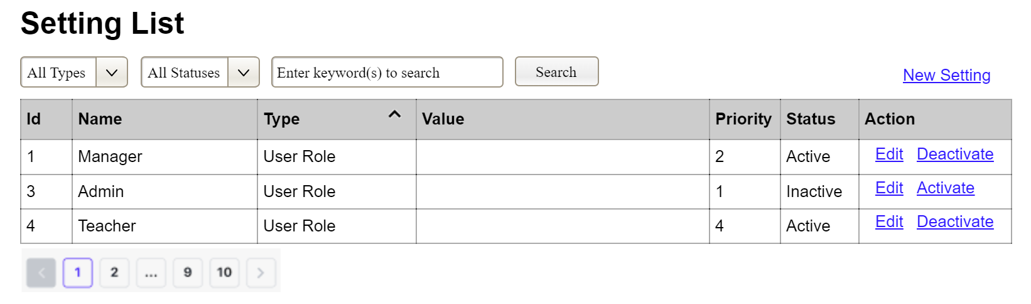
(3)
(2)
(1)
This screen allows the Administrator to:
- View Setting List: view list of current master data.
- Filter Setting List: filter master data by data types, statuses
- Search Settings: enter keyword(s) to search master data by their names or values
- Sort Setting List: sort mater data list (ascending, descending) by clicking column headers
On the screen, s/he can also
- Activate/Deactivate Setting: change status of a specific inactive/active master data
- Choose to go to the Setting Details screens for adding new or updating an existing master data by clicking the New Setting or Edit link.
Field Description
Field Name | Description
(1) | Initial values: all the active setting names with null or blank type  Hover the mouse to show the field name: “Setting Type”
(2) | Initial values: All Statuses, Active, Inactive (default value “All Status”)  Hover the mouse to show the field name: “Setting Status”
(3) | The change-status action is Activate or Deactivate depending on the current status of the relevant setting (Inactive or Active, respectively).

3.1.2 Setting Details
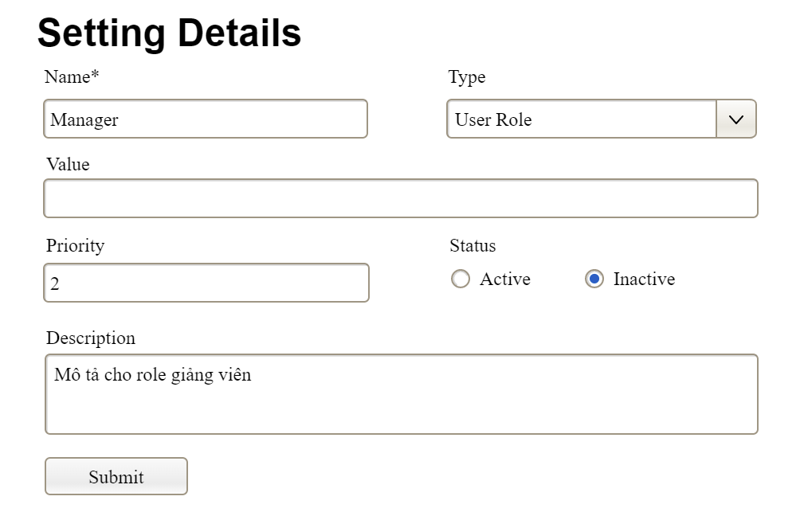
This screen allows the Administrator to:
- Add New Setting: add new master data.
- Update Setting Details: update details of a specific master data
Field Description
Field Name | Description
Name | Data type: non-digit string, max length of 20 characters
Type | Initial data values: all active setting names (with null or blank type)
Value | Data type: any string, max length of 100 characters
Priority | Data type: a positive integer
Description | Data type: any string, max length of 200 characters

3.2 User Management

3.2.1 User List
…

3.2.2 User Details
…

4. Feature NameN
…

5. Background Job Inventory

5.1 Unlock Expired Locked Accounts (JOB-01)
Trigger: Scheduled — every 15 minutes
Purpose: Automatically unlocks accounts that were locked after failed sign-in attempts, once the lockout duration has elapsed
Processing steps:
- Find all accounts with status = Locked where the lockout timestamp is more than 10 minutes ago.
- For each account found: reset the failed sign-in count to zero, set status back to Active.
- Log the number of accounts unlocked in this run.
Failure behavior:
Scenario | System behavior
Database unreachable | Job retries up to 3 times with 30-second intervals. If still failing, logs a critical error. Accounts remain locked until the next successful run.
No locked accounts found | Job completes immediately with no action — this is normal and expected.

5.2 Clean Up Old Audit Log Entries (JOB-02)
Trigger: Scheduled — daily at 2:00 AM
Purpose: Removes audit log entries older than the configured retention period to prevent unbounded database growth.
Processing steps:
- Determine the configured log retention period (default: 90 days).
- Find all audit log entries with a timestamp older than the retention threshold.
- Delete the old entries in batches of up to 5,000 records per run — to avoid locking the database for an extended period.
- If records remain after one batch, schedule the next batch to run 5 minutes later rather than deleting everything at once.
- Log the total number of entries deleted and the number of batches processed.
Failure behavior:
Scenario | System behavior
Database timeout during delete | Current batch rolled back. Job logs a warning. Tries again at the next scheduled time. No data corruption.
Retention period not configured | Job uses default of 90 days and logs a warning that the setting was not found.

6. External API Inventory

6.1 HTTP Method: URL pattern (API-ID)
URL | HTTP method: URL pattern
Purpose | Purpose in one plain-language sentence
Caller | Who the caller is (which external system)
Auth | Authentication requirement (yes/no + type)

6.2 VnPay Webhook (API-02)
URL | POST: /api/v1/commerce/payment/webhook/vnpay
Purpose | Receives payment confirmation (IPN) from VNPay; triggers access grant creation
Caller | VNPay payment gateway
Auth | HMAC-SHA512 signature validation

6.3 SePay Webhook (API-03)
URL | POST: /api/v1/commerce/payment/webhook/sepay
Purpose | Receives payment confirmation from SePay; triggers access grant creation
Caller | SePay payment gateway
Auth | HMAC signature validation

IV. Non-Functional Requirements

1. External Interfaces
[This section provides information to ensure that the system will communicate properly with users and with external hardware or software/system elements.]

2. Quality Attributes
[List all the required system characteristics (quality attributes) specification. Some of the possible attributes are provided with the guide/descriptions are mentioned here]

2.1 Usability
[This section includes all those requirements that affect usability. For example, specify the required training time for a normal user and a power user to become productive at particular operations specify measurable task times for typical tasks or base the new system’s usability requirements on other systems that the users know and like specify requirement to conform to common usability standards, such as IBM’s CUA standards Microsoft’s GUI standards]

2.2 Performance
[The system’s performance characteristics are outlined in this section. Some samples are as below]
Requirement | Target | Condition
Page load time | Any page loads within 2 seconds | Up to 100 users active simultaneously
Form submission response | System acknowledges within 2 seconds | Up to 100 users active simultaneously
Maximum simultaneous users | System remains fully functional for up to 100 users | Single server deployment

2.3 Security
[State the requirement of security, not the implementation mechanism. Some samples are as below]
Requirement | Description
Authentication required | Every page and action other than the sign-in page, registration page, and public job listings requires the user to be signed in.
Password protection | Passwords must never be stored in a form that a person or program can read.
Account lockout | After a defined number of consecutive failed sign-in attempts, the account is temporarily locked. Threshold and duration defined in TDS §4.
CV file access | CV files may only be accessed by users with permission to view the associated Application. The system verifies permission on every access.

V. Requirement Appendix
[Provide business rules, common requirements, or other extra requirements information here]

1. Business Rules
[Provide common business rules that you must follow. The information can be provided in the table format as the sample below]
GBR-ID | Rule Statement | Applies To | Rationale | Enforced By
GB-01 | Status changes are one-way and permanent. No status may be reverted to a previous value. | Job posting status, Application status, Interview status | Prevents data integrity loss; maintains clear audit trail. | The system automatically on every status change
GB-02 | Internal Notes are never visible to Candidates, regardless of how they access the system. | All views accessible to Candidates | Allows HR to write candid internal assessments. | The system automatically on every page and data request
GB-03 | CV files may only be accessed by staff with permission to view the associated Application. Access verified on every download. | All CV file access | Protects Candidates' personal data from unauthorised access. | The system automatically on every file access request
GB-04 | When a sign-in fails, the message must not reveal whether the username exists or the password was wrong. | Sign-in | Prevents attackers from discovering valid usernames. | The system automatically on every failed sign-in
GB-05 | A deactivated account cannot sign in, regardless of password correctness. | Sign-in | Ensures departed staff lose access immediately. | The system automatically on every sign-in attempt
GB-06 | An Interviewer may only access Applications they have been explicitly assigned to. | Application access | Maintains pipeline confidentiality; prevents evaluation bias. | The system automatically on every Application access request

2. System Messages
# | Message code | Message Type | Context | Content
1 | MSG01 | In line | There is not any search result | No search results.
2 | MSG02 | In red, under the text box | Input-required fields are empty | The * field is required.
3 | MSG03 | Toast message | Updating asset(s) information successfully | Update asset(s) successfully.
4 | MSG04 | Toast message | Adding new asset successfully | Add asset successfully.
5 | MSG05 | Toast message | Confirming email of asset hand-over is sent successfully | A confirmation email has been sent to {email_address}.
6 | MSG08 | In red, under the text box | Input value length > max length | Exceed max length of {max_length}.
7 | MSG09 | In line | Username or password is not correct when clicking sign-in | Incorrrect user name or password. Please check again.
8 | ..

3. Other Requirements
…

